Video Transcripts and Captions
Video transcripts and captions are important because they enable greater comprehension for all users and they make video content searchable.

If you have a video that is more than 5 minutes long, it may be worthwhile to use a transcription and/or captioning service. A transcript is the text version of an audio or video file. Captions are subtitles that are attached and synched to a video. Caption files include the same text that you would find in a transcript with the addition of timecode that synchs text to the video.

At this time, typical transcription and captioning services cost between $1 and $3 per minute of audio or video footage. You can save money and time creating captions if you already have a script that you used to produce the audio or video. If you do not have a script, having a transcript produced for an audio file is sufficient. Producing a transcript of a video may also be sufficient, but if you would like to have the video captioned, then producing a transcript is part of the process of producing captions. Sometimes a transcript of a video file is all you need, but usually the best practice, if you are producing the video, is to create both a transcript and captions for your video. If you want to make someone else’s video accessible without their assistance, you may only be able to produce a transcript. While services are likely to change over time, here are some reasonably priced captioning services to get you started:

- Rev (~$1/minute)
- 3PlayMedia (~$3/minute)
- CaptionSync (~$1-$3/minute)
- Speechpad (~$1/minute)

Do It Yourself Captions
Doing it yourself may be worthwhile if you have a short audio or video file. Doing your own captions is a two-step process:

- Transcribe your audio or video. If you prepared a script before creating your podcast or video, you can tweak your script to make an accurate transcript. When transcribing, be sure to include sound effects and other important descriptions.
- Create a caption file. To add captions to a video, synch the transcript to your video by setting beginning and end points, also called timecode, and then attach the captions file to the video.
After you learn to use one of the free transcription and captioning tools, plan to spend 5-10 times the duration of the podcast or video to create your transcript and captions. For example, plan to spend between 30 minutes and an hour to create a transcript and captions for a 5-minute video. If your podcast or video is 20 minutes or longer, doing it yourself becomes a significant time commitment. At this point, it may be more cost effective to employ a service.

Here are two simple approaches you can use to create your own transcripts and captions. You can upload a short podcast or video directly into Canvas and use Canvas’ integration with Amara. If you are creating your own video, you can use YouTube.

Using Canvas’ integration with Amara
Canvas’ integration with Amara allows you to upload a video directly into Canvas. The integration directs you to Amara, gives you what you need to get started in Amara, and then accepts the caption file you create in Amara and attaches it to your video in Canvas. This process is recommended for short videos (up to 5 minutes long):
- Upload video or audio using Canvas’ Media Tool. This is the Canvas Media Tool icon: . Anytime you see this icon on a page or in the ruler of the rich text editor in Canvas, you will be able to record and/or directly upload video or audio into Canvas:
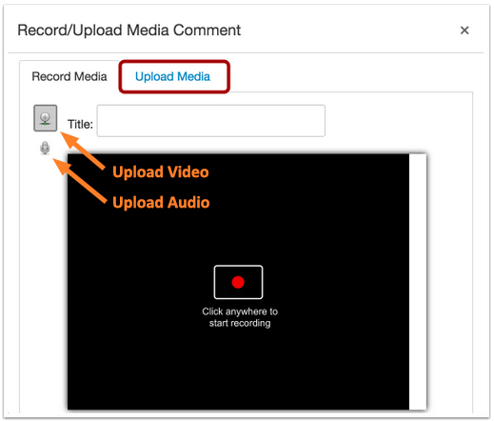
Figure 1
- Once your video or audio file is successfully uploaded to the Canvas page, click on the media file to play. At the bottom of the media player, click on the CC icon (1) and select Upload Subtitles (2).
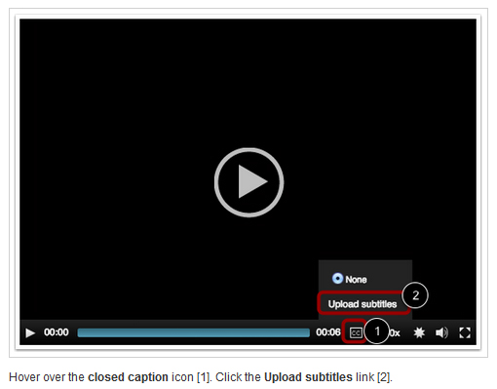
Figure 2
- Doing this gives you the view you the Create/Add Subtitles view (see Figure 3), which details the steps you need to take to get you to Amara and the information you will need once you get started in Amara. In an effort to make more video and audio accessible worldwide, the non-profit organization Amara provides the tools to make transcriptions and captions. You can also pay Amara to generate transcripts and captions for you. When you use the link provided in Canvas, you will be taken directly to Amara. To use the tools once you are there, begin by creating a free user account.
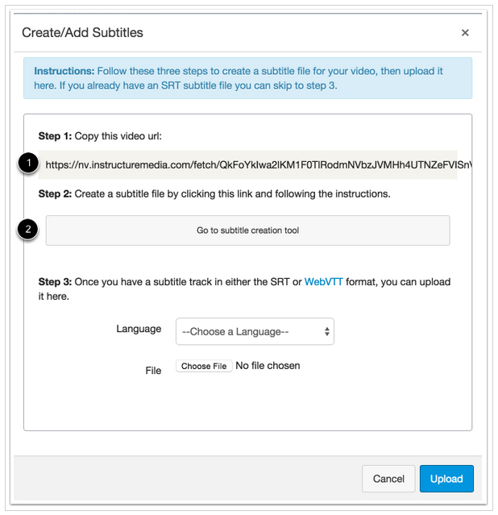
Figure 3
- Once you have an Amara account, you can enter the URL provided by Canvas (see Figure 3, Step 1):
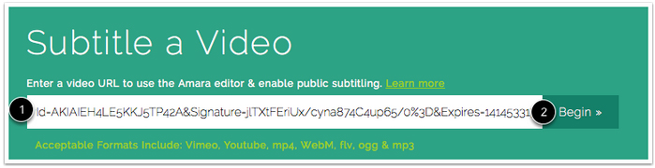
Figure 4
- After you submit the Canvas URL, Amara will direct you to a videos page. When you finish creating your captions file, you can download that file by opening the language link you will see on the video page. The language link will be English, unless you are creating captions in another language. The first time you create a new captions file, select Add a new language (see Figure 5):
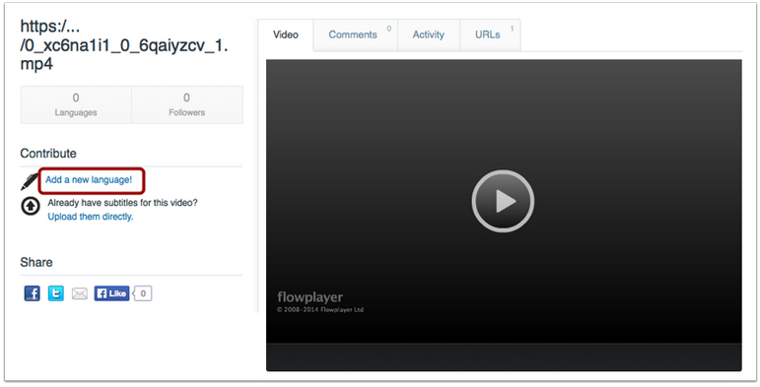
Figure 5
- When you select your language Amara opens the transcription/captioning tool (see Figure 6):
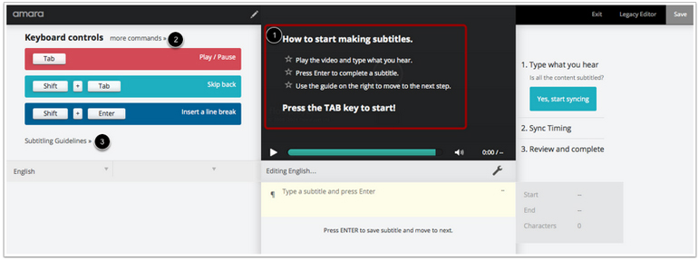
Figure 6
- The first time you access this tool, consult the guides and Help resources on the site. When you finish creating your transcript and your captions, you will be able to download a TXT transcript file that includes only the caption text or an SRT caption file that includes the text and any timecode you set. To attach the captions to your video in Canvas, download the SRT file to your desktop.
- Return to Canvas (see Figure 3 above), and complete Step 3. To attach the captions to your video, choose the correct language and upload the SRT file from your desktop.

Using YouTube
To use the transcription and captioning tools in YouTube, you must have rights to the video in question. You can either create your own YouTube account, or you can login to an existing account and create transcripts and captions for video content in that account. Once a video is uploaded:

- YouTube will automatically caption the video using voice recognition software. The captions on an auto-captioned video are surrounded with audio icons that look like parenthesis – ((( see Figure 4 below ))) – If you don’t have a script, you can start with these auto-generated captions.
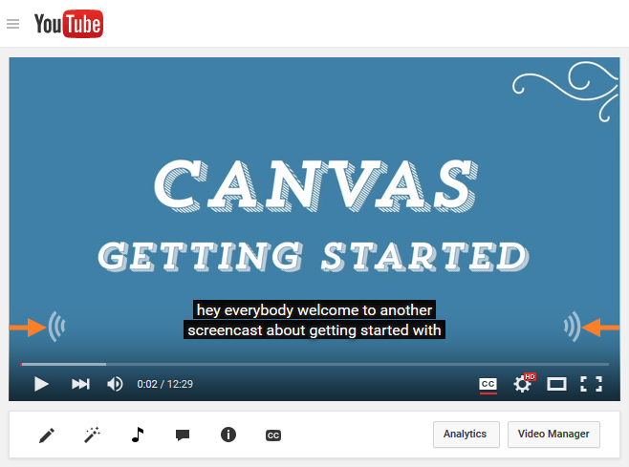
Figure 7
- From the Video Manager in YouTube, find your video, and select Edit next to thumbnail image of your video.
- From this general edit window, select “Subtitles and CC” to go to “Manage subtitles and closed captions.” (see Figure 8).
- You can do several things from the “Manage subtitles and closed captions” view. If you click on “English (Automatic),” you can edit the auto-generated captions. You can also upload a script and work with the text of that file to create new captions, or you can create new captions by entering new text while you play the video. In addition to creating English captions, you can also create subtitles in another language (see Figure 8).
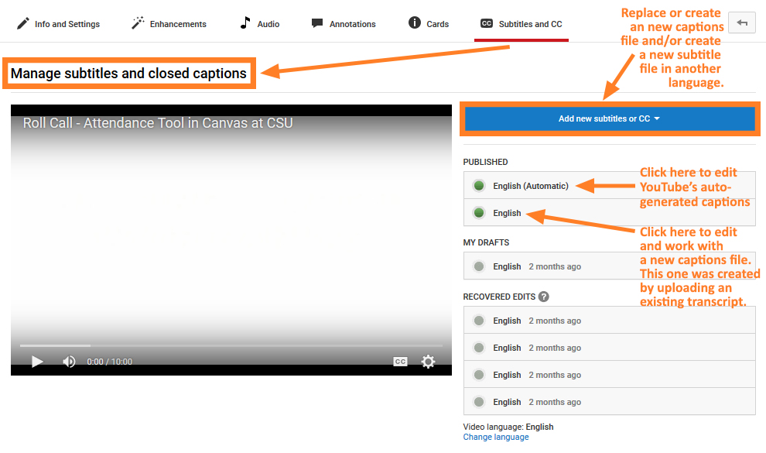
Figure 8
- In the example below, the user selected the auto-generated English file, English (Automatic). To edit the captions to the right of the video, select Edit at the bottom right corner of the page. You can then play the video and add new text or edit existing captions. You edit the time code by selecting the caption blocks below the video and sliding the start and end points for each block. Be sure to save and publish your changes.
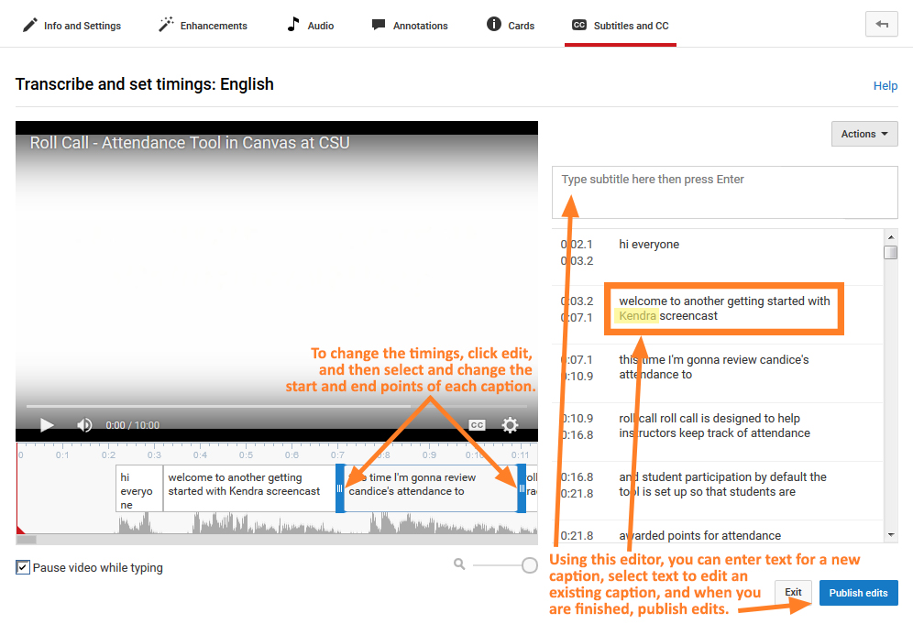
Figure 9
- Finally, if you want to download a transcript based on your work in the captions editor, go to the video on YouTube, select “… More” (More actions), and then select Transcript. You will then be able to select, copy, and paste the captions text into your own document. To transform the captions text into a transcript, remove the time code and reformat into a standard text document.
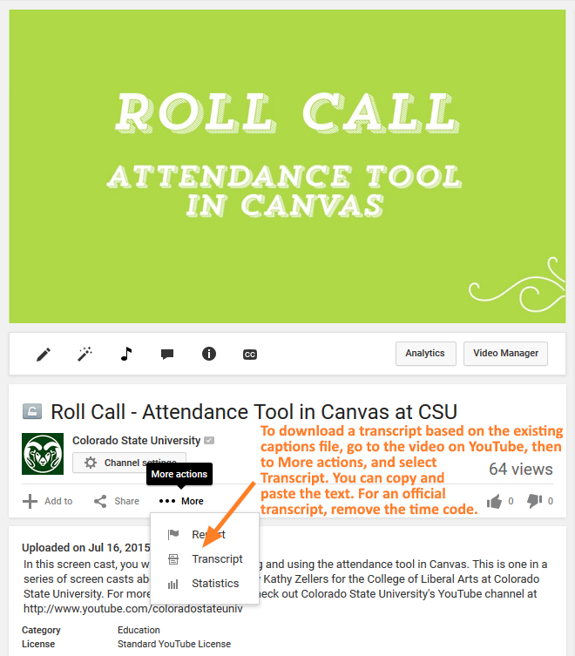
Figure 10

